**Dr Hadjichristofis Stelios FCS(SA)Orth. / MMed(WITS)Orth cell: 00357 99722555 www.bonejointcyprus.com**

**AMERICAN MEDICAL CENTER. Room 105. Phone: 22476874 / 615**

**Acute fracture scaphoid. New non-invasive method.**

**Fracture scaphoid without displacement. Minimally invasive fixation. Acute percutaneous fixation of the scaphoid fracture with canulated headless compression screw has been done as a means to minimize some of the complications of closed treatment - delayed union, non-union, malunion, cast induced joint stiffness and lost time from employment and avocations.**

**We have done two patients the last 3 weeks and we are using it as a standard treatment option for a selected group of patients with acute scaphoid fracture.**

**1.**

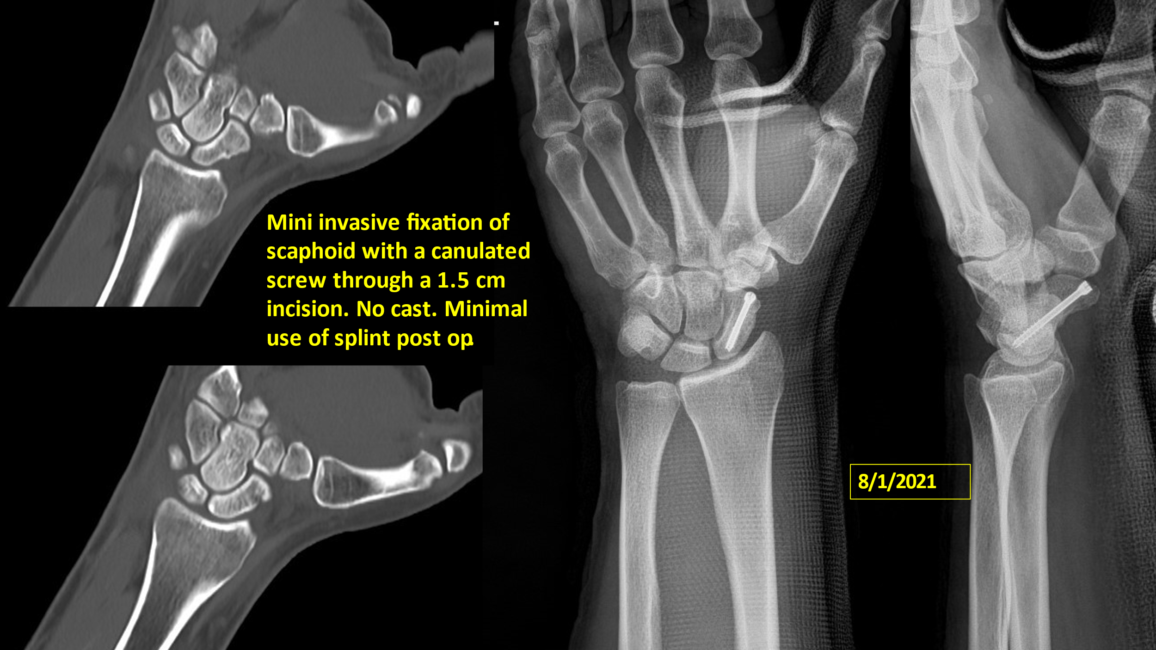

**2.**

